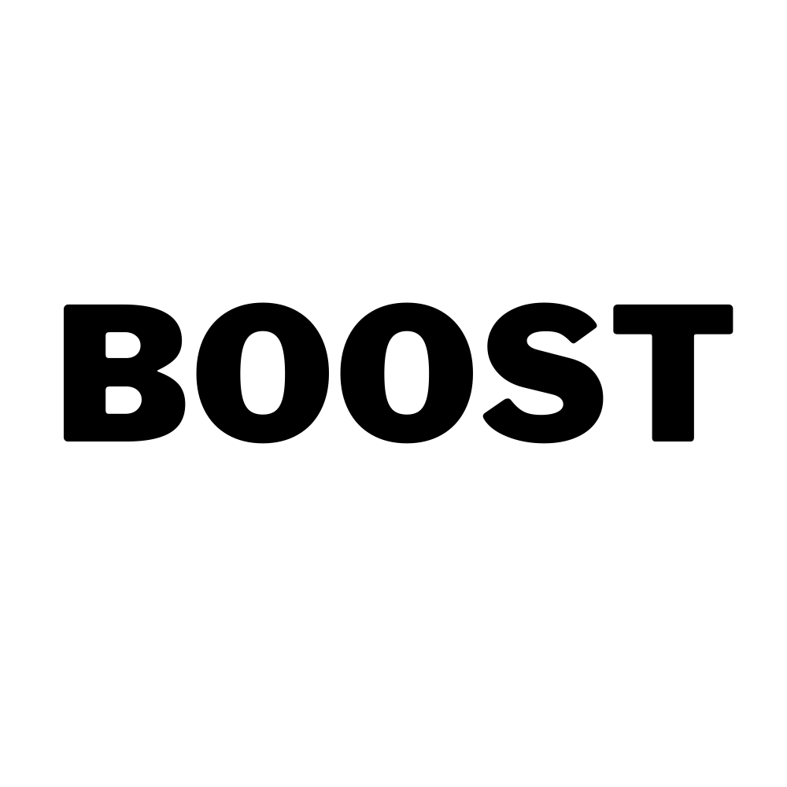Breathing space - Free Yoga

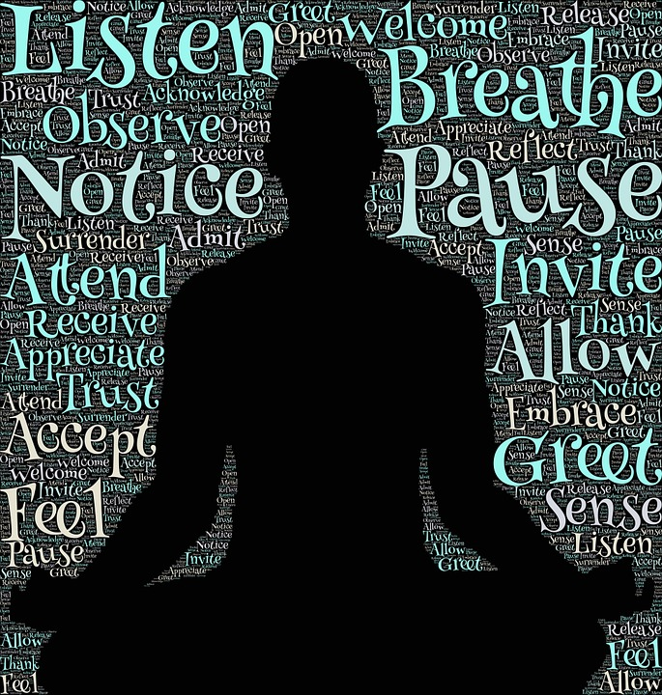funded by **this girl can & Boost** with Rebecca @ Pause Yoga

## **Final 3 funded sessions September 6, 13 and 20th**

## Time to focus on yourself

## Breathing practices that support emotional wellbeing

## Gentle Yoga suitable for beginners

If you have felt the **effects of** **social isolation** or believe your **mental & emotional wellbeing is in need of a boost**, then this free, funded class for women 18years+ is for you. Our classes aim to inspire, reassure & support people be active & promote connection.

**Comments from previous & current Pause Yoga students taken from the website**

* Afterwards I feel stretched and calm.
* I suffer a lot with anxiety and found the breathing techniques really help.
* I feel stronger mentally and physically & we have a little giggle along the way.
* I particularly enjoy the soothing relaxations.
* I can go at my own pace.

## Places are available @ Evolution Martial Arts, Hadfield (Yoga mat supplied) **Every Monday 11:00-12:00** Contact [pauseyogaglossop@gmail.com](mailto:pauseyogaglossop@gmail.com) to book your place.